Password & Access Policy

Project Overview :
It is a good practice to change your password every 90 days. It makes it significantly harder for an attacker to compromise an account using old or static credentials.

Task A:Governance (Policy)
- Passwords must be changed in 90 days.
- After 5 failed login attempts, Wazuh will generate the alert.

Task B:Monitoring

Passwords must be changed in 90 days.
It is a good practice to change your password after 90/3 months. Because it becomes difficult for hackers to guess your password after a long time.

For it open your terminal and navigate to the login.defs file which is in the /etc directory.
Command : sudo nano /etc/login.defs (find PASS_MAX_DAYS)
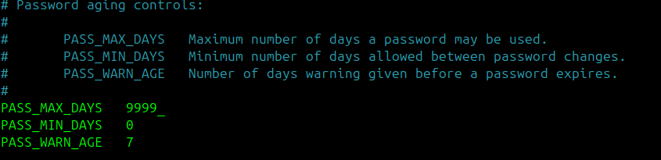
Figure 1 : Configuration of PASS_MAX_Days

After reaching out to the pin point change these 9999 days to 90 days

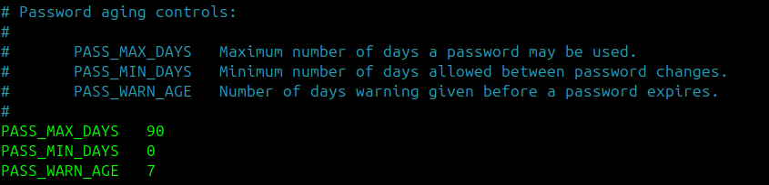
Figure 2: Configuration of PASS_MAX_DAYS to 90 to meet AC-1 requirements

Save the file and Exit (Press Ctrl+X –> Y and Enter)

Failed Login
Why ?
In wazuh there is already a login failed rule then why do we need to add the second rule.

Reason :
Yes , That’s right! There are already rules for login failed in wazuh not any who tell us that does the login attempt is simple( by user ) or brute force attack that is why we need another rule who works as a parent rule and the wazuh default rule 5760 works as a child rule. If the child rule fires many times one after another then the parent rule works as a high alert. So that’s why we need it.

Solution :
Navigate to the xml file of the wazuh
Command : sudo nano /var/ossec/etc/rules/local_rules.xml
At the bottom past this rule :

<group name="syslog, authentication_failures,">
<rule id="100005" level="10" frequency="5" timeframe="120">
<if_matched_sid>5760</if_matched_sid>
<description>5 failed login attempts (hacker you might take a little break)</description>
<group>authentication_failed,pci_dss_10.2.4,pci_dss_10.2.5,</group>
</rule>
</group>
Save the file and Exit (Press Ctrl+X –> Y and Enter)

After the new rule addition restart the wazuh manager
Command : sudo systemctl restart wazuh-manager

Now do some failed login attempts
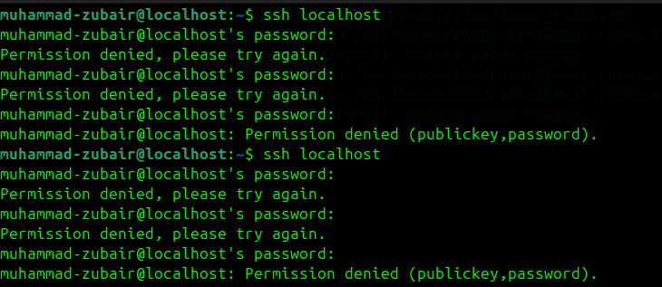
Figure : 3 Failed login attempts

Open your wazuh dashboard and see the logs

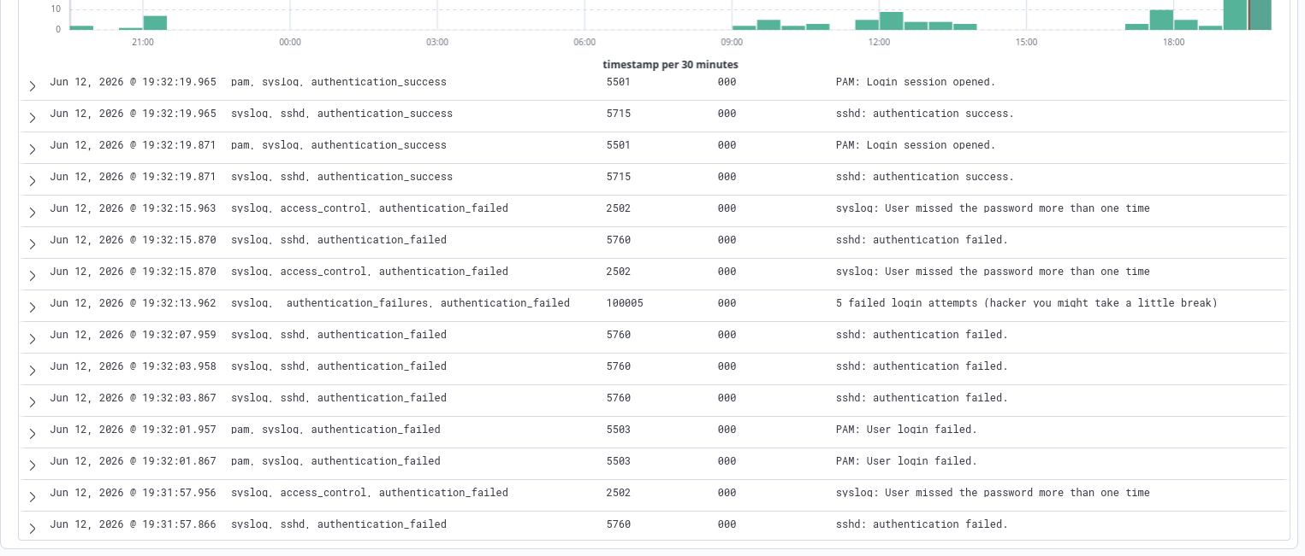
Figure : 4 screenshot of wazuh dashboard

In the above Screenshot you can see that our custom rule is successfully fired. It means our rule is working perfectly.

Compliance

Control ID | Policy Description | Status | Evidence(wazuh)
AC-1 | Password Policy (90 days) | compliant | System configured via /etc/login.defs with PASS_MAX_DAYS=90. Configuration verified against organizational policy (Ref: Figure 2)
AC-2 | Login Failure (5 attempts) | compliant | Wazuh custom rule ID 100005 implemented to detect 5 failed login attempts within 120 seconds.(Ref: Figure 4)

